10/19/2026
Instructor: Sir Mustajab
Submitted by: Wasif Ali
Reg id: 245187
Class: BSCS F24 B


A*,GBFS
Artificial Intelligence Lab 07
Lab No 07
Lab Task 1:
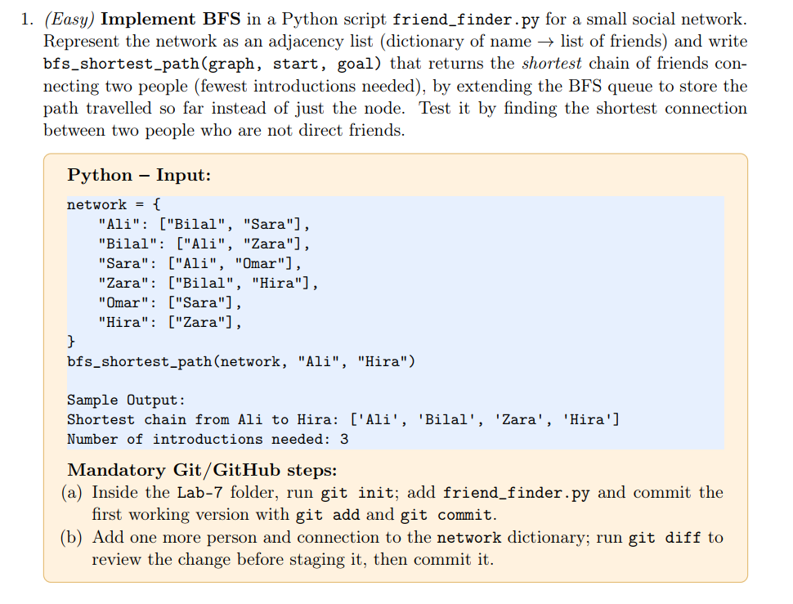
Code:
def bfs_shortest_path(graph, start, goal):

visited = [start]
queue = [[start]]

while queue:

path = queue.pop(0)
node = path[-1]

if node == goal:
return path, len(path) - 1

for neighbour in graph.get(node, []):
if neighbour not in visited:
visited.append(neighbour)
queue.append(path + [neighbour])

return None, 0

network = {
"Ali": ["Bilal", "Sara"],
"Bilal": ["Ali", "Zara"],
"Sara": ["Ali", "Omar"],
"Zara": ["Bilal", "Hira"],
"Omar": ["Sara"],
"Hira": ["Zara"],
}

path, introductions = bfs_shortest_path(network, "Ali", "Hira")
print(f"Shortest chain from Ali to Hira: {path}")
print(f"Number of introductions needed: {introductions}")

Output:
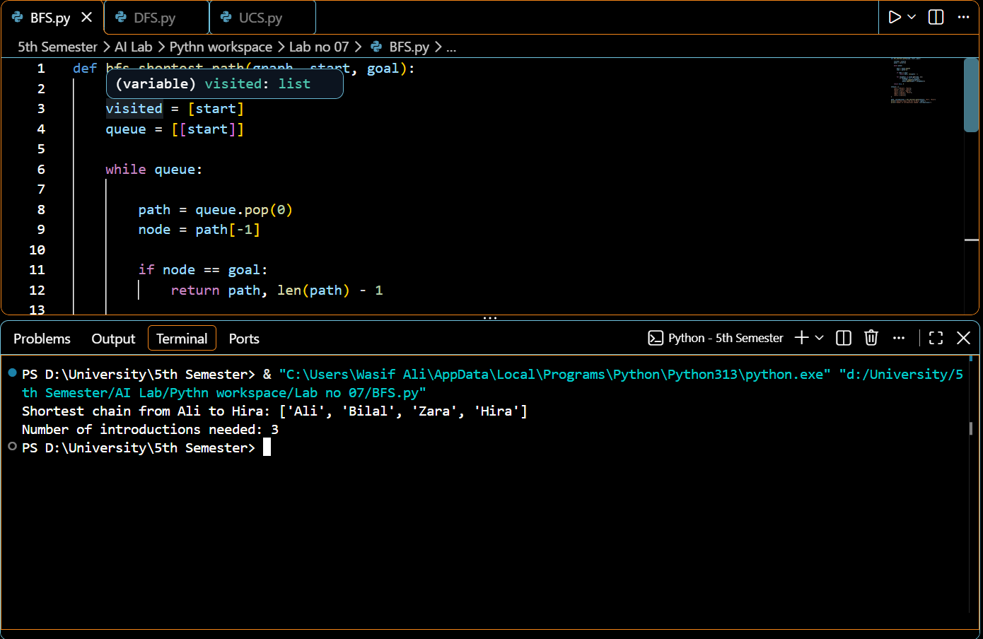
Lab Task 2:
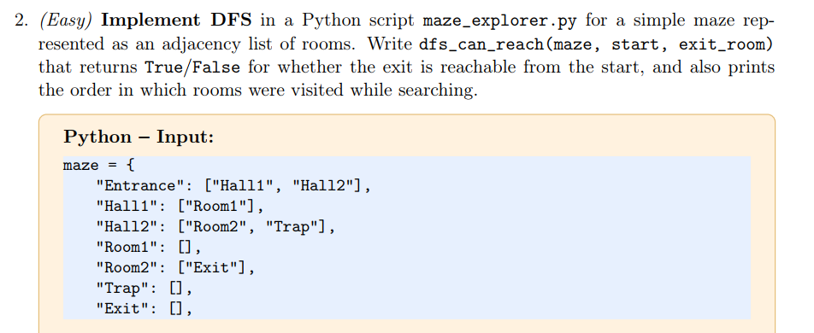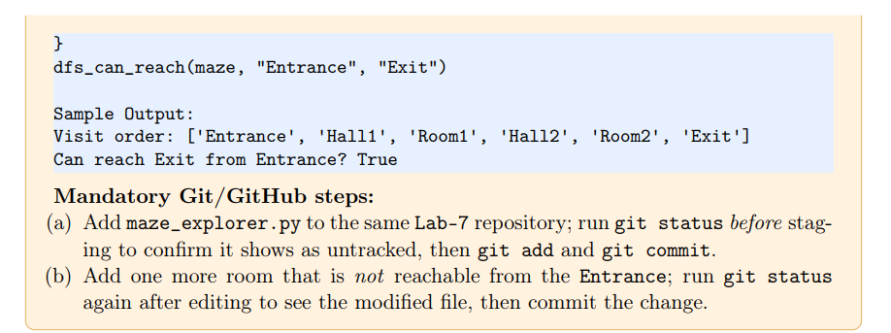
Code:
def dfs_can_reach(maze, start, exit_room):
visited = []

def dfs(node):
if node not in visited:
visited.append(node)
if node == exit_room:
return True
for neighbour in maze.get(node, []):
if neighbour not in visited:
if dfs(neighbour):
return True
return False

reachable = dfs(start)
print(f"Visit order: {visited}")
print(f"Can reach {exit_room} from {start}? {reachable}")
return reachable

maze = {
"Entrance": ["Hall1", "Hall2"],
"Hall1": ["Room1"],
"Hall2": ["Room2", "Trap"],
"Room1": [],
"Room2": ["Exit"],
"Trap": [],
"Exit": [],
}

dfs_can_reach(maze, "Entrance", "Exit")

Output:
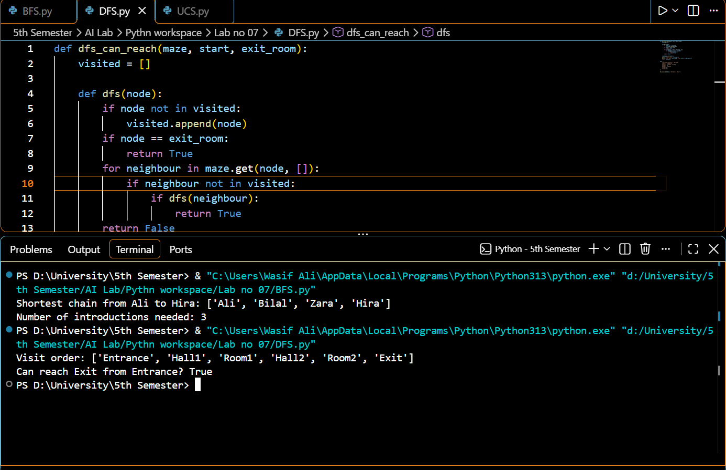

Lab Task 3:
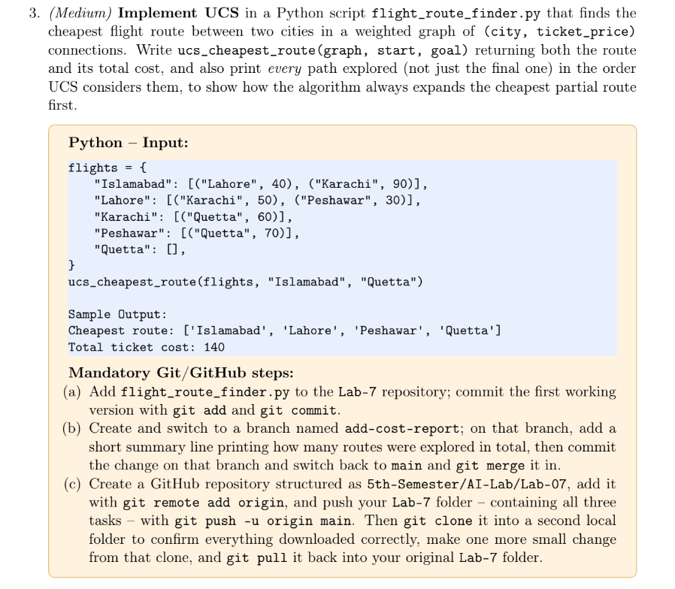
Code:
def path_cost(path):
return sum(cost for _, cost in path)

def ucs_cheapest_route(graph, start, goal):
visited = []
queue = [[(start, 0)]]

while queue:
queue.sort(key=path_cost)
path = queue.pop(0)

route_nodes = [node for node, cost in path]
current_cost = path_cost(path)
print(f"Exploring route: {route_nodes} with cost: {current_cost}")

node = path[-1][0]

if node in visited:
continue
visited.append(node)

if node == goal:
return route_nodes, current_cost

for neighbour, cost in graph.get(node, []):
queue.append(path + [(neighbour, cost)])

return None, None

flights = {
"Islamabad": [("Lahore", 40), ("Karachi", 90)],
"Lahore": [("Karachi", 50), ("Peshawar", 30)],
"Karachi": [("Quetta", 60)],
"Peshawar": [("Quetta", 70)],
"Quetta": [],
}

best_path, best_cost = ucs_cheapest_route(flights, "Islamabad", "Quetta")
print(f"Cheapest route: {best_path}")
print(f"Total ticket cost: {best_cost}")

Output:
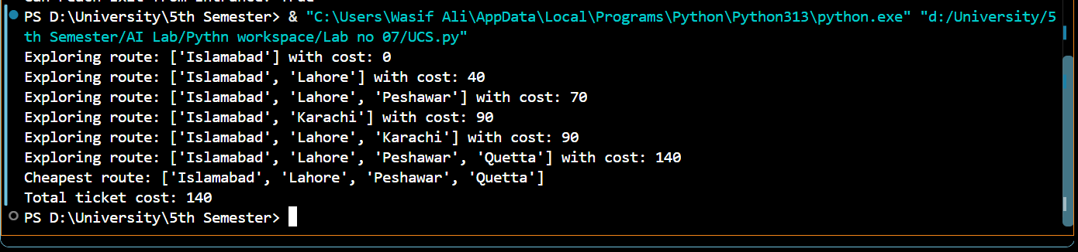

Git Hub Push:
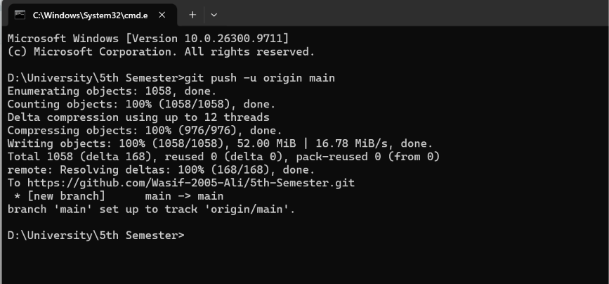
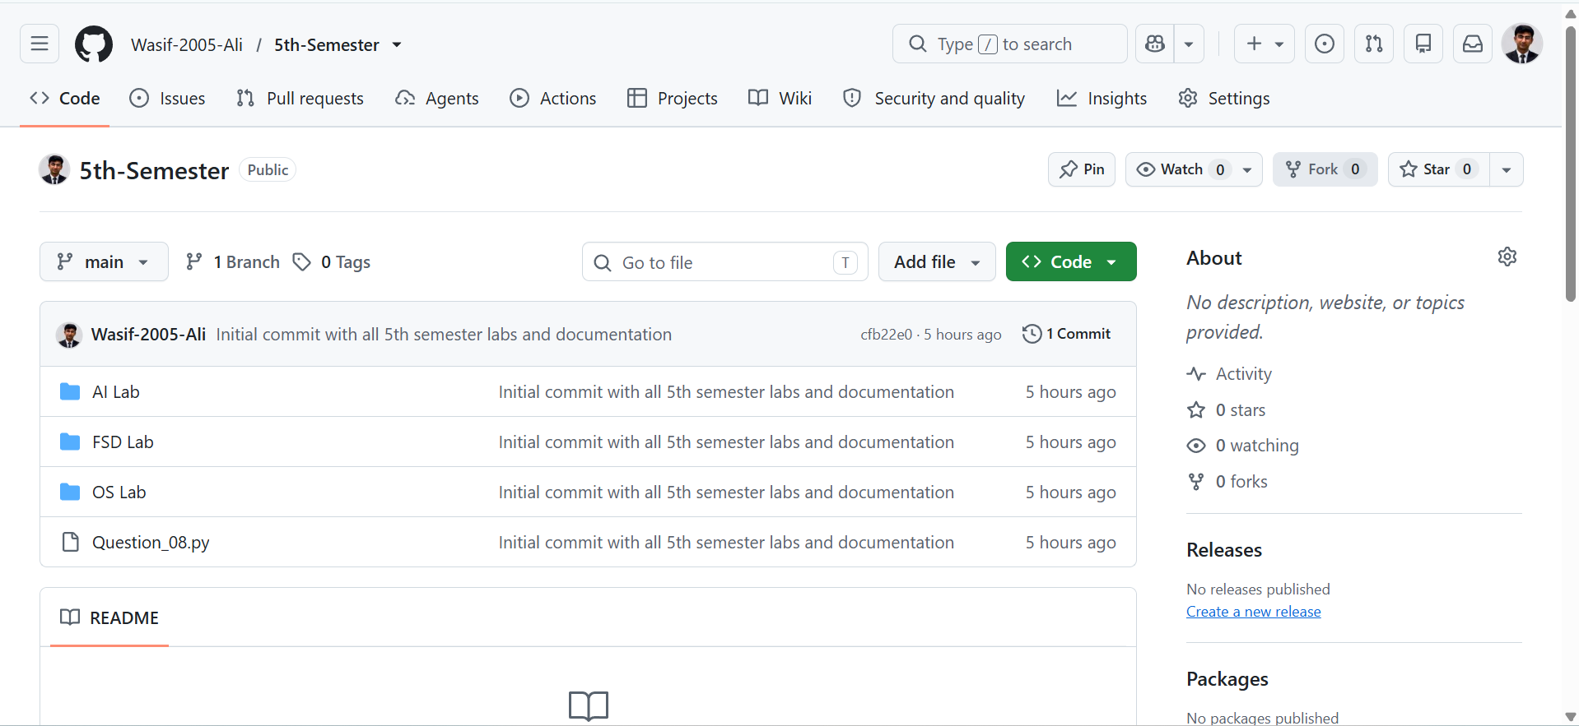
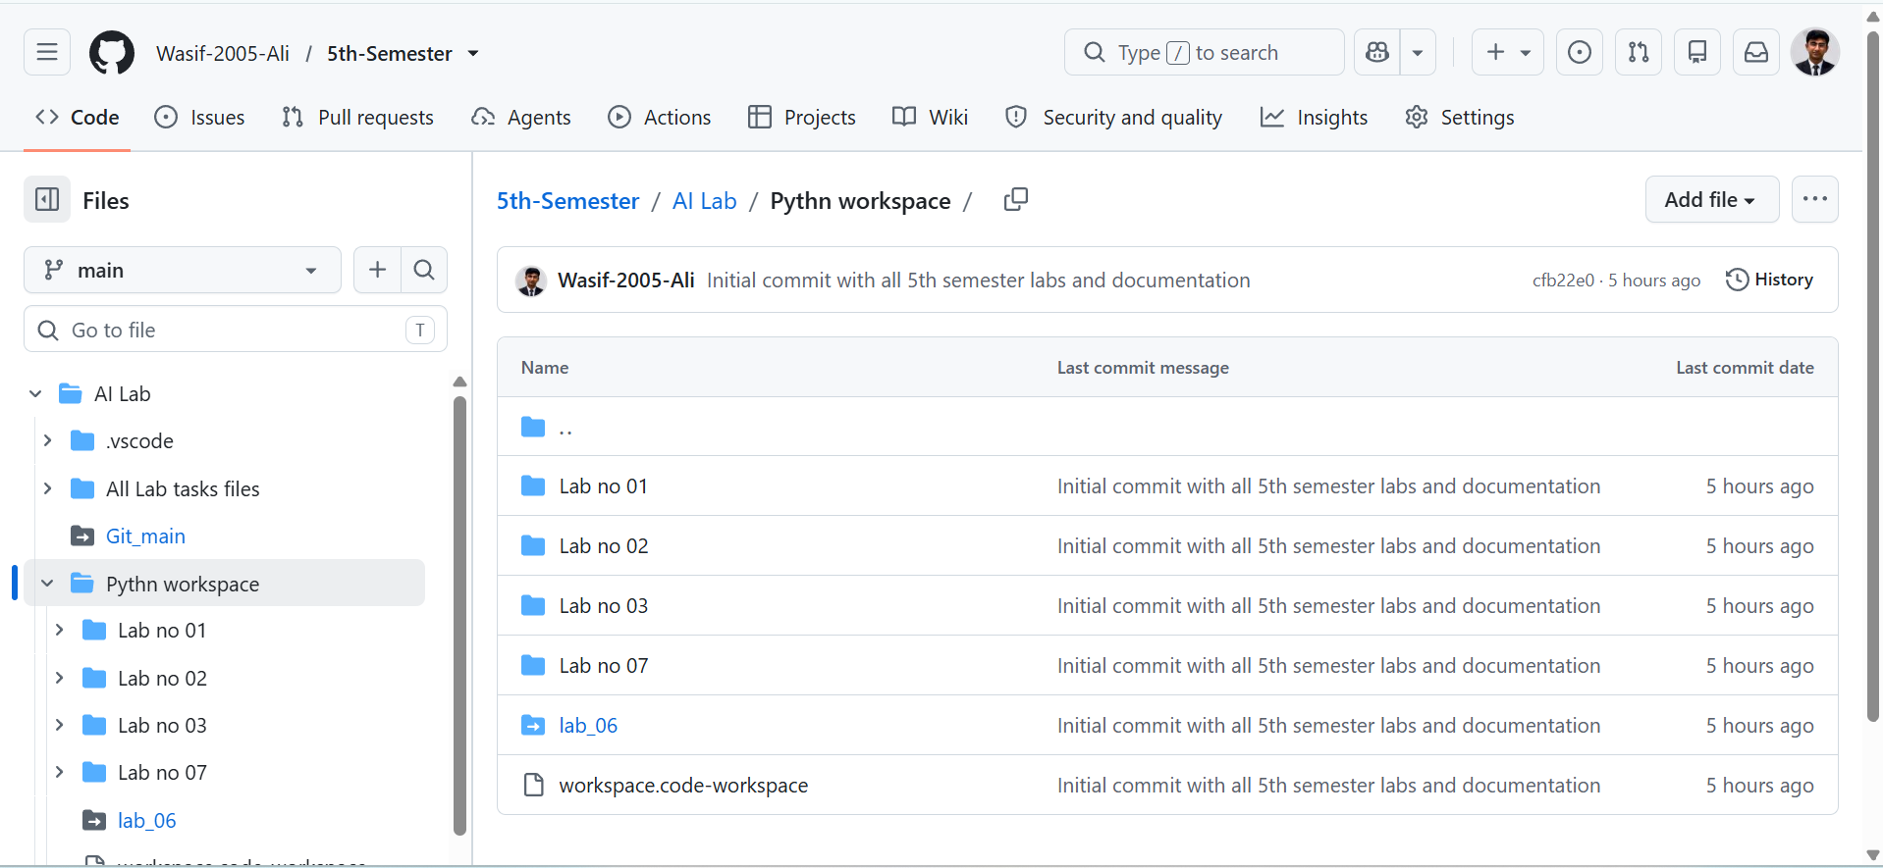
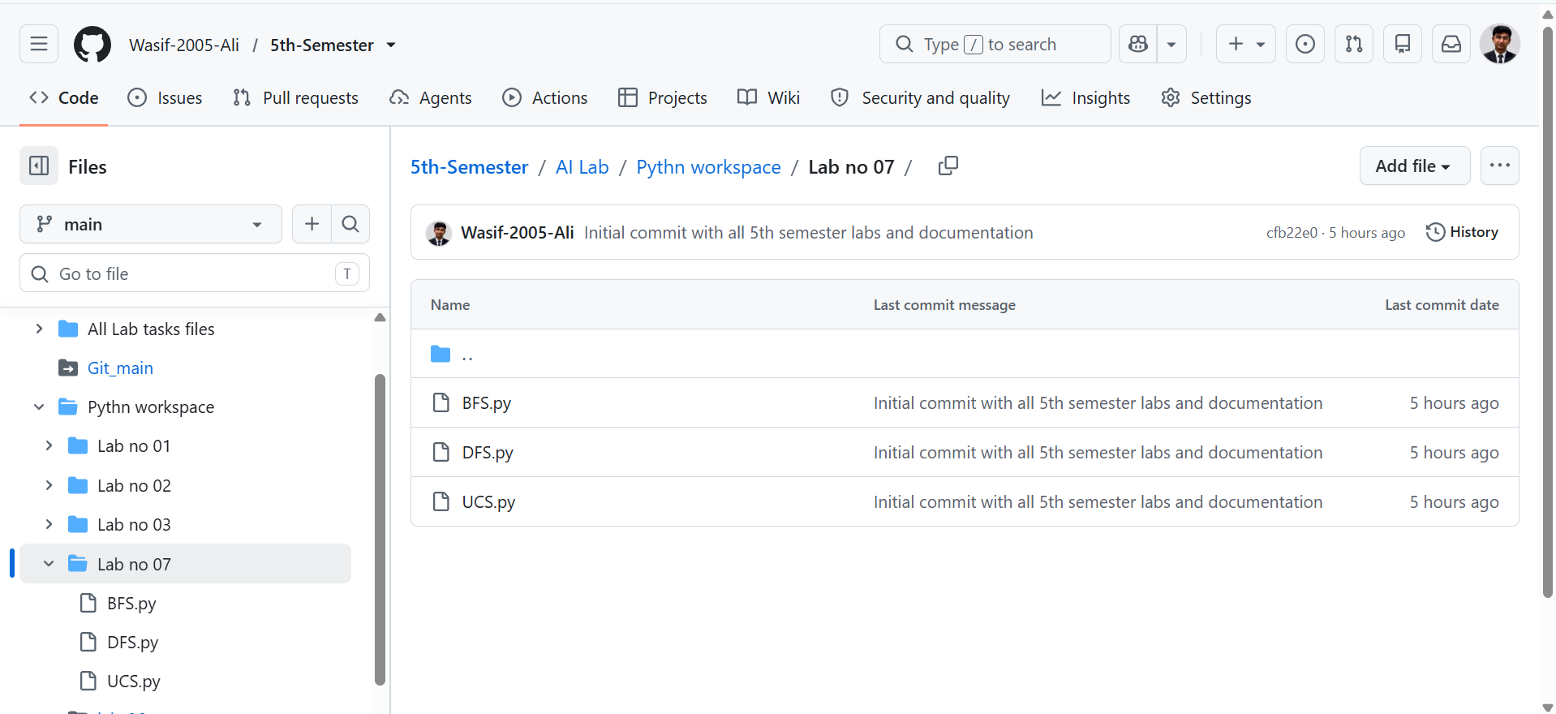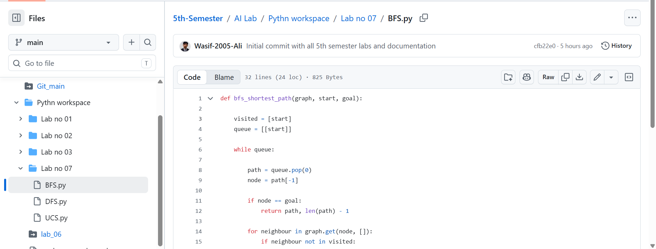
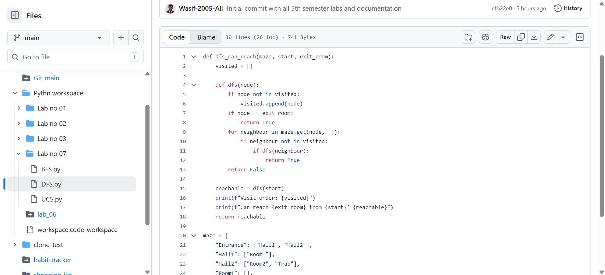
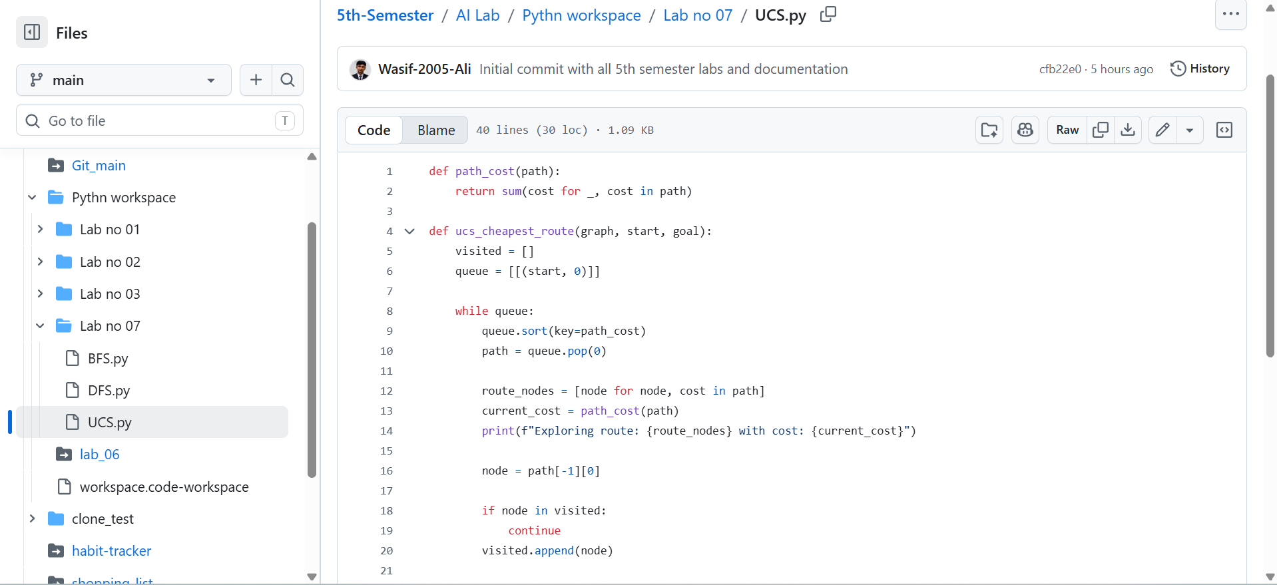

ALL TASK COMPLETED SUCCESFULLY

